**Channon Harper s3871491**

I am 33 years old born 1987 in Bacchus Marsh Vic now currently residing in Greenmount QLD, I am married and a father of 1 dad of 2, I am also a proud member of ‘The Flying Mongooses’. My hobbies include fishing, camping, making things with my hands, as well as messing around with programs and software to see what can be done with them. My interests in IT is all to do with the programming side of things as well as the vulnerabilities that some systems have, also gaming everyone loves gaming. My experience is all self-taught if there is anything, I don’t understand I typically just sit and learn it by any means necessary. I have previously made RPG, side scrollers, and text-based games, I also have knowledge in the use of all main software be it office 365, Eclipse or Atom to name a few. After completing this course, I will have my first qualification in this field and will also be doing some Cybersecurity Certifications.

**Personal Profile**

I believe the results from my 3 tests are fairly accurate to how I perceive myself within reason some of the results I find to be most useful are as follows. Introverted I do not believe the results here were accurate I do consider myself an introvert however in a dynamic where I previously know someone or get to know someone I have no troubles starting a conversation or joining in one. Judging I am always concerned someone may take something I say the wrong way and knowing this about me will hopefully assure them its just my personality everyone is intitled to an opinion I want to assure them of that. Intuitive I usually just go straight at something thinking I am doing the right thing but in the same sense if I am not and can be logically explained quickly, I accept my faults. This information may benefit the group as from it they can determine a role suitable to my personality. I do not believe it replaces knowing someone because the results are limited, they can also be contradicted in certain circumstances as depending on the situation your personality may change.

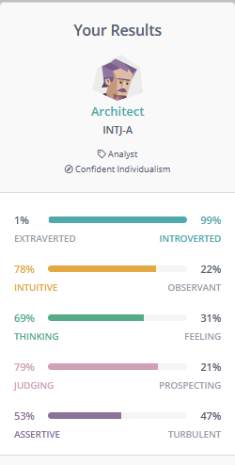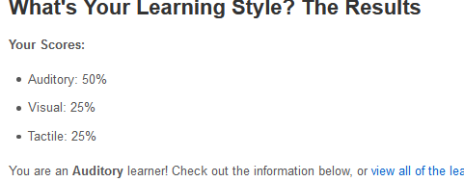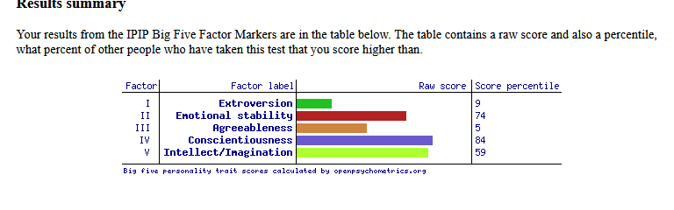

**Ideal Job**

My ideal job is Cyber Security Analyst. The position of cyber security analyst is to find vulnerabilities and exploits in IT infrastructure. To protect from any cyber-attacks that are occurring or may occur in the future to stay ahead of the hackers and implement fixes to prevent any intrusion. I believe my Ideal Job holds similarities to Adams as it has a lot of programming language based knowledge. There is some overlap of similarities with the others however the main goals are very different. To my understanding Maddie’s, Daniel’s, Sam’s and Jorge’s all hold very similar aspects of work.